13th July 2026

Dear Parent / Carer,

Uniform Expectations

This letter is intended to help inform your choices when purchasing school uniform and shoes, so that these are fully in line with the academy’s expectations. The school uniform code clearly sets out the requirements of Beacon Hill Academy. We have extremely high standards and expectations in relation to uniform, and we ask for your support in ensuring that these expectations are upheld and that learners do not contravene these stipulations.

Uniform & Shoes

- Full school uniform, including the blazer, must always be worn or carried in all areas of the academy. With permission, learners are allowed to remove their blazer in lessons. In warmer weather, learners are permitted to carry their blazer around school.

- Learners must only wear black trousers or skirts. Trousers should be tailored, not stretch, and full length, reaching the bottom of the ankles. They should have some give around the ankles for comfort. Piping on trousers is not permitted.

- Learners are also expected to wear plain black socks as part of the academy uniform.

- If a learner wears a skirt, it must always reach at least the top of the knee, including when walking. It is unacceptable for the skirt only to be the correct length if the learner pulls it down. A variety of skirt styles are permitted within school, including box pleats and A-line skirts. Pencil stretch skirts are not permitted. Leggings, denim and jeans are also not permitted. Some learners may wear a plain black Shalwar Kameez.

- Learners are permitted to wear knitted V-neck jumpers alongside their blazers, but these jumpers should not be considered a substitute for them.

- Learners are to wear formal, smart, black leather or patent shoes. Learners are not permitted to wear trainers or other canvas footwear. This includes black leather trainers, including those without markings. School shoes should have no visible branding, whether the branding is a different colour or black, including Nike ‘ticks’ or sporting logos. A phrase/question we often use with learners to provide clarity is: “If you painted them white, would they still look like shoes? If so, then they are shoes. If, when painted white, they look like trainers, they are not appropriate school shoes.”

- Boots are not acceptable (a boot is defined as anything that touches or comes above the ankle bone).

Please see below the examples of footwear that are and are not acceptable.
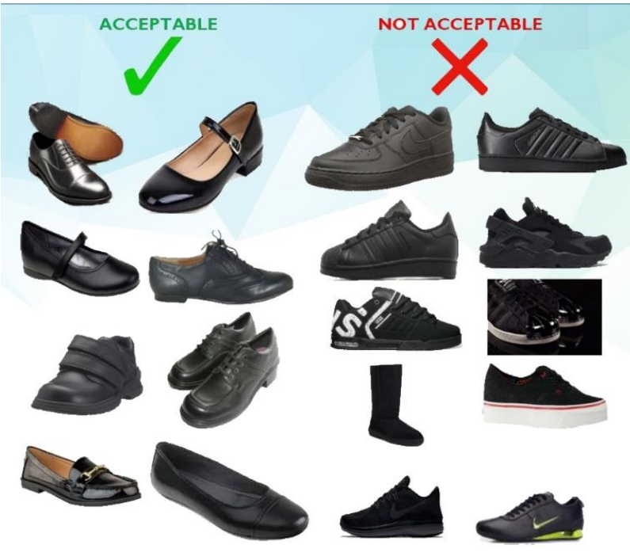

Jewellery and Accessories

- Jewellery is limited to one small, plain metal stud in each ear lobe. No facial piercings are permitted, for example nose studs. Stretcher-style piercings are not permitted in any circumstances. Jewellery cannot be worn during PE lessons. If jewellery is worn for medical reasons, suitable medical evidence identifying the reasons for this must be provided to the school.

- As stated in the previous bullet point, it is important to note that nose rings, studs or clear articles of jewellery which affix to the nose or face are not permitted under any circumstances. This includes ‘retainers’.

- Hair accessories such as bows, flowers and wide bands are not permitted; thin ‘Alice bands’ may be worn. Only natural hair dyes are permitted. This also includes hair extensions or braids. Hair should be no shorter than grade 1 and no design lines or patterns are allowed.

- A plain black head covering for religious purposes is permitted; however, additional close-fitting cloths, such as durags, are not allowed to be worn on the school site.

- Outdoor coats must be removed once inside the school building. Denim/leather jackets and hoodies are NOT to be brought into school.

- Learners are not permitted to wear nail varnish and acrylic/false nails must be removed for school.

- False eyelashes are not permitted as part of the school uniform policy.

- All learners are expected to bring a suitable school bag each day to carry the equipment they need for all subjects. This forms an important part of being fully prepared for learning and meeting the academy’s expectations for equipment and uniform.

PE Kit.

- PE kit is also available from Crested School Wear, Churchill Shopping Centre, Dudley, 01384 918 330. The make and style of PE kit has not changed; however, the new arrangement with Crested allows kit to be sampled and tried for size in store locally.

- The minimum and compulsory requirement for PE kit is a Beacon Hill Academy branded polo shirt and Beacon Hill Academy branded shorts with plain black socks. Other BHA branded items are available but are not compulsory.

- If learners are injured or unable to take part in PE, it is expected that they bring a note from home, along with their Beacon Hill Academy PE kit. This will ensure they are changed out of their school uniform and are actively involved in the lesson through a number of different roles. Your child’s PE teacher will reinforce this expectation upon their return in September.

- Please note that no other sports wear other than mentioned above is expected.

- If learners choose to wear leggings or other undergarments (e.g. skins) for PE, these must be plain black and worn underneath the academy PE kit, for example underneath PE shorts.

- In terms of appropriate footwear, both trainers and football boots are essential items of kit for all learners. Each learner will take part in both football and rugby/tag rugby on our school field, at various points through the school year. Health and safety of our learners is of upmost importance meaning that football boots must be worn during football and rugby lessons.

Values-driven behaviour expectations and technology/mobile phones.

- The academy continues to operate the Values Driven Expectation system. We expect the highest standards of our learners in terms of their attitude to learning, their conduct towards each other and our staff, and the pride they show in wearing the academy’s uniform.

- Mobile phones/iPads/iPods/MP3/4 players and headphones cannot be used at any time on the school site. They will be confiscated if seen, and learners will be issued with a detention. Smart watches may be used, but their functionality at school must be limited to reading the time.

Raising Standards, Rewarding Success

- As communicated to learners during Thursday’s virtual assembly, we will be introducing a small number of refinements to further strengthen our learning culture and provide even greater support for learners.
- These include changes to the parking system, the introduction of a termly non-negotiable focus, and an adjustment to our Supporting Expectations provision, which will now conclude at 3.20pm to allow for additional support and intervention where needed.
- We are also delighted to announce that our brand-new Merit Shop is ready to launch, with further details and exciting updates to follow in September.

Over the summer holiday, we will continue to send out further communications. In the meantime, if you have any queries, please email support@beaconhillacademy.org.uk.

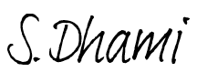
Yours sincerely,

Mr Dhami
Principal

